**ENGN2520 Homework 3**

**Ming Xu (Banner ID: B01532164)**

**Problem1**

***(a)***

We know that: $p\left(w|T\right)∝p\left(T|w\right)*p(w)$, where

$p\left(w\right)$ is the priori distribution of ***w*** and $w \sim N(w|0,aI)$. In this case:

$$p\left(w\right)= \frac{1}{{\left(2π\right)}^{\frac{D}{2}}}*\frac{1}{{\left|aI\right|}^{\frac{1}{2}}}*\exp\left\{-\frac{1}{2}w^{T}(a{I)}^{-1}w\right\}=\frac{1}{{\left(2π\right)}^{\frac{D}{2}}}*\frac{1}{a^{\frac{D}{2}}}*\exp\left\{-\frac{1}{2a}w^{T}w\right\}$$

$$=\frac{1}{{(2πa)}^{D/2}}*exp\{-\frac{1}{2a}w^{T}w\}$$

$p\left(T|w\right)$ is the likelihood. In this case:

$$p\left(T|w\right)=\prod_{i=1}^{N}{P\left(y_{i} | x_{i},w\right)}= \prod_{i=1}^{N}{\frac{1}{\sqrt{2πσ}}exp\{-\frac{{(y_{i}-f_{w}(x_{i}))}^{2}}{2σ^{2}}\}}$$

Combine the equations above:

$$p\left(w|T\right)∝\frac{1}{{(2πa)}^{D/2}}*exp\{-\frac{1}{2a}w^{T}w\}*\prod_{i=1}^{N}{\frac{1}{\sqrt{2πσ}}exp\{-\frac{{(y_{i}-f_{w}(x_{i}))}^{2}}{2σ^{2}}\}}$$

Let $L\left(T,w\right)$ be the right part the equation above, in this case:

$$L(T,w)=\frac{1}{{(2πa)}^{D/2}}*exp\{-\frac{1}{2a}w^{T}w\}*\prod_{i=1}^{N}{\frac{1}{\sqrt{2πσ}}exp\{-\frac{{(y_{i}-f_{w}(x_{i}))}^{2}}{2σ^{2}}\}}$$

The MAP estimate of ***w*** is the vector maximizing the posterior probability of ***w*** given ***T***:

$$w_{MAP}=\max_{w}{p\left(w|T\right)}=\max_{w}{L(T,w)}$$

Denote $l(T,w)$ as the log of $L\left(T,w\right)$, then:

$$l\left(T,w\right)= -\frac{D}{2}*\log\left(2πa\right)+-\frac{1}{2a}w^{T}w+\sum_{i=1}^{n}{(log}\frac{1}{\sqrt{2πσ}}-\frac{{(y_{i}-f_{w}(x_{i}))}^{2}}{2σ^{2}})$$

Ignore the constant times to get $\hat{l}(T,w)$:

$$\hat{l}\left(T,w\right)= -\frac{1}{2a}w^{T}w-\sum_{i=1}^{n}{\frac{{(y_{i}-f_{w}(x_{i}))}^{2}}{2σ^{2}}}$$

Therefore,

$$w_{MAP}=\max_{w}{L(T,w)}= \min_{w}\{\frac{1}{2a}w^{T}w+\sum_{i=1}^{n}{\frac{{(y_{i}-f_{w}(x_{i}))}^{2}}{2σ^{2}}}\}$$

Let $λ=\frac{σ^{2}}{a}$, then $w_{MAP}$ can be written as:

$$w_{MAP}=\min_{w}\{\frac{λ}{2}w^{T}w+\frac{1}{2}\sum_{i=1}^{n}{{(y_{i}-f_{w}(x_{i}))}^{2}}\}$$

***(b)***

$$λ=\frac{σ^{2}}{a}$$

**Problem2**

Let $x_{i}$ be the ***ith*** training data from the data set ***T***. The likelihood can be written as:

$$L\left(u|T\right)=P\left(T | u\right)=\prod_{i=1}^{k}{P\left(x_{i} | u\right)}=\prod_{i=1}^{k}{P\left(x_{i} | u\right)}$$

Note that, from a data $x_{i}$, there are n features, namely $\{x_{i}^{\left(1\right)},x_{i}^{\left(2\right)}…x_{i}^{(n)}\}$.

Also, $x_{i}^{\left(j\right)}$ distributed according to a Bernoulli distribution with mean $u_{j}$, then:

$$P\left(x_{i} | u\right)=\prod_{j=1}^{n}{P\left(x_{i}^{\left(j\right)} | u_{j}\right)}=\prod_{j=1}^{n}{u_{j}^{x_{i}^{\left(j\right)}}*{(1-u_{j})}^{{1-x}_{i}^{\left(j\right)}}}$$

Therefore,

$$L\left(u|T\right)= \prod_{i=1}^{k}{\prod_{j=1}^{n}{u_{j}^{x_{i}^{\left(j\right)}}*{(1-u_{j})}^{1-x_{i}^{\left(j\right)}}}}$$

Denote $l(T,u)$ as the log of $L\left(T,u\right)$, then:

$$l\left(T,u\right)=\sum_{i=1}^{k}{\sum_{j=1}^{n}{x_{i}^{\left(j\right)}*log⁡(u_{j})}}+\sum_{i=1}^{k}{\sum_{j=1}^{n}{(1-x_{i}^{\left(j\right)})*log⁡({1-u}_{j})}}$$

Taking the derivative of this expression with respect to $u_{j}$, we get:

$$\frac{∂l}{∂u_{j}}=\sum_{i=1}^{k}{\sum_{j=1}^{n}{x_{i}^{\left(j\right)}*\frac{1}{u_{j}}}}-\frac{1-x_{i}^{\left(j\right)}}{{1-u}_{j}}=0$$

Let $k_{j}=\sum_{i=1}^{k}{\sum_{j=1}^{n}{x_{i}^{\left(j\right)}}}$, which is the total number of ones in the ***jth*** feature of all the data in the training set.

$${\hat{u}}_{MLE}^{(j)}=\frac{k_{j}}{n}$$

**Problem3**

***(a)***

The result is very similar the result of Problem2.

The maximum likelihood estimate for parameters $u_{y,i}$ is:

$${\hat{u}}_{MLE}^{(y,i)}=\frac{k_{i}}{n}$$

Where n is the number of training data of class $y$ and $k_{i}$ is the total number of ones in the $ith$ pixel of the training set.

***(b)***

The visualization of the models is shown as below:

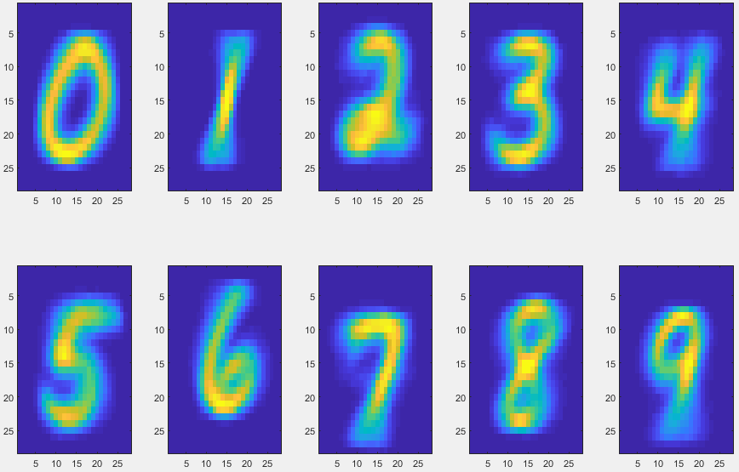

***(c)***

The total number of testing data that is correctly classified is 3942, so the fraction is 78.84%.

The confusion matrix is show as below:

|  |  |  |  |  |  |  |  |  |  |  |
| --- | --- | --- | --- | --- | --- | --- | --- | --- | --- | --- |
|  | **0** | **1** | **2** | **3** | **4** | **5** | **6** | **7** | **8** | **9** |
| **0** | 433 | 0 | 4 | 0 | 2 | 33 | 13 | 0 | 14 | 1 |
| **1** | 0 | 470 | 2 | 3 | 0 | 14 | 4 | 0 | 7 | 0 |
| **2** | 16 | 12 | 370 | 36 | 8 | 2 | 6 | 11 | 32 | 7 |
| **3** | 1 | 10 | 4 | 414 | 6 | 23 | 6 | 13 | 10 | 13 |
| **4** | 4 | 1 | 11 | 0 | 360 | 6 | 13 | 4 | 7 | 94 |
| **5** | 19 | 1 | 3 | 66 | 19 | 344 | 7 | 5 | 16 | 20 |
| **6** | 13 | 8 | 30 | 0 | 6 | 33 | 407 | 0 | 3 | 0 |
| **7** | 8 | 16 | 8 | 4 | 15 | 0 | 2 | 389 | 9 | 49 |
| **8** | 4 | 16 | 13 | 50 | 13 | 18 | 1 | 4 | 346 | 35 |
| **9** | 3 | 7 | 4 | 8 | 49 | 7 | 0 | 7 | 6 | 409 |

***(d)*** Source code

**1.** **Function to train the classification model: “trainModelForDigit.m”**

function [model] = trainModelForDigit(trainSet)

[rowNum, ~] = size(trainSet);

model = sum(trainSet)/rowNum;

end

**2. Function to calculate the probability of the given data and given class:” calculateProbability.m”**

function [probability] = calculateProbability(data,model)

result1 = model.^data;

model = 1-model;

data = 1-data;

result2 = model.^data;

result = result1.*result2;

probability = prod(result);

end

**3. Function to classify the testing set by models trained on the training set:” classifyDigit.m”**

function [classifyResult] = classifyDigit(testData,models)

%initialization

[dataCount,~] = size(testData);

result = zeros(dataCount,10);

classifyResult = zeros(1,10);

%loop all testing data

for row = 1:dataCount

%loop each class to calculate probability

for col = 1:10

result(row,col) = calculateProbability(testData(row,:),models(col,:));

end

%find the max value and index of the probability

[~, index] = max(result(row,:));

%classify

classifyResult(1,index) = classifyResult(1,index) + 1;

end

end

**4. Main function:”main.m”**

load 'digits';

models = zeros(10,784);

%% Train model for each digit

for i = 1:10

traindata = sprintf('%s%d','train',i-1);

models(i,:) = trainModelForDigit(eval(traindata));

end

%% Draw the visualization of the models

for i = 1:10

subplot(2,5,i);

imagesc(reshape(models(i,:),28,28)');

end

%% Classify each testing set

confusion = zeros(10,10);

correct = 0;

for i = 1:10

testdata = sprintf('%s%d','test',i-1);

confusion(i,:) = classifyDigit(eval(testdata),models);

correct = correct + confusion(i,i);

end